Signup and login process

Landing page =>

1. Enter valid referral code to continue.

2. Click on the submit button.

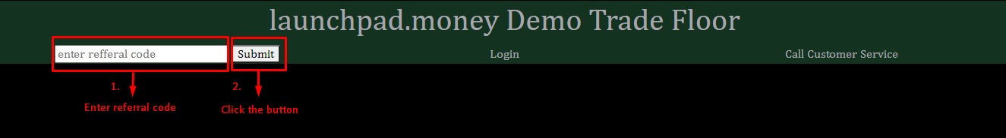

Signup page =>

1. Fill up all the fields to continue.

2. Click on the submit button.

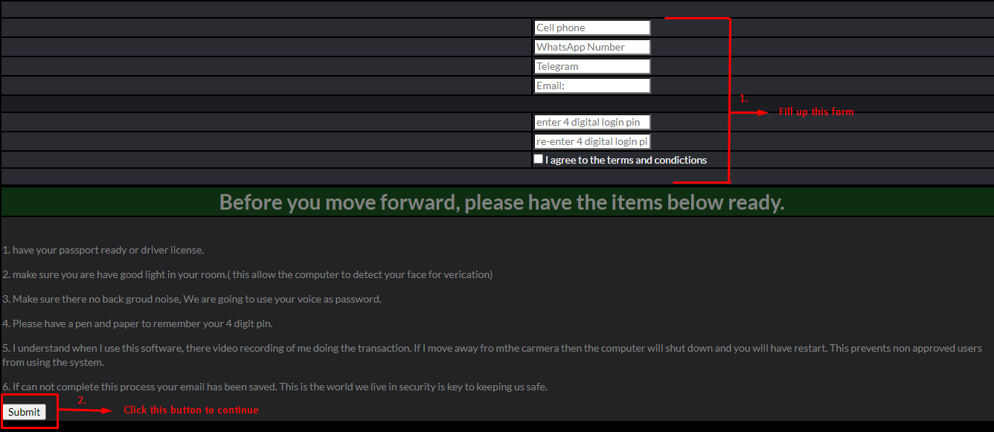

Document verification page =>

1. For face and voice activation, click on this button. You will be redirected to another page.

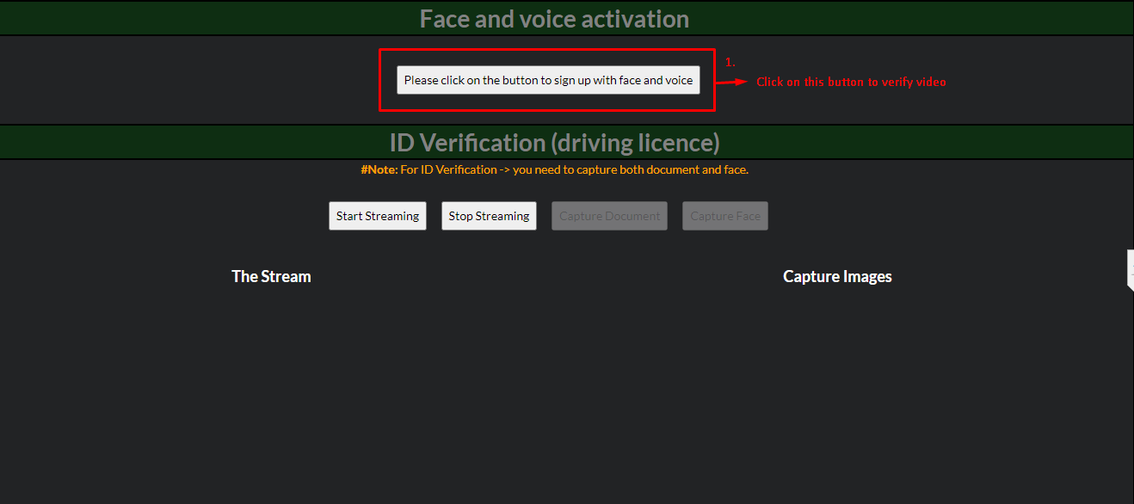

From the redirected page =>

1. Select a phrase from the dropdown menu. This phrase is required when you start recording.

2. Click here to start recording. You need to speak with the selected phrase and make sure that your face is in front of camera.

3. Click here to stop recording.

4. Click here to sign up with face and voice

5. Click here to reset camera. Repeat step 1 to 5 three times to activate.

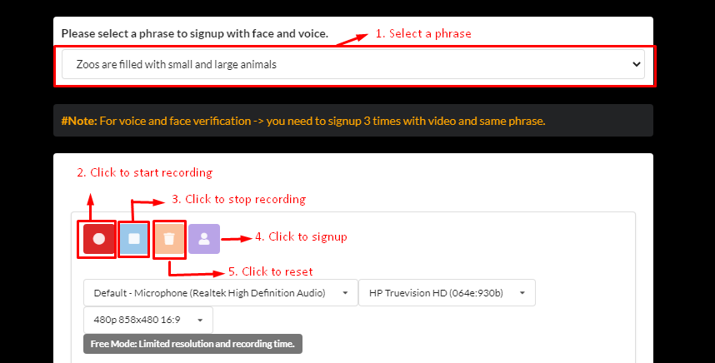

Again from Document verification page =>

1. Click here to open camera.

2. Click here to capture document (driving license).

3. Click here to capture face.

4. Click here to verify face and document.

5. Click here to close camera.

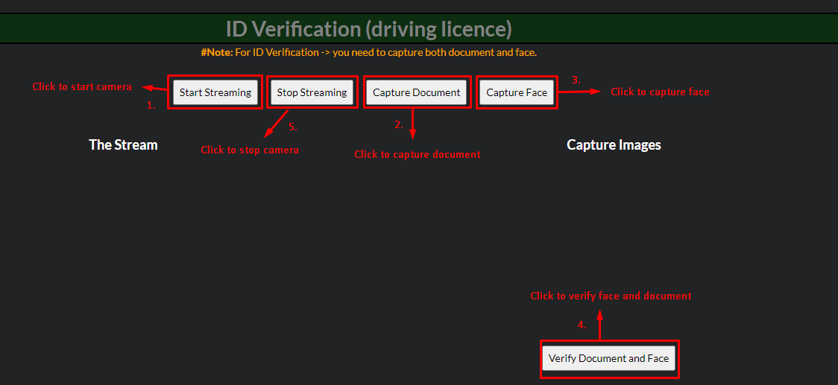

**#Note:** Same process (driving license) is applicable for passport verification.

From Login page

1. First of all, you need to put your email address and 4 digit pin to continue. These are taken while registration.

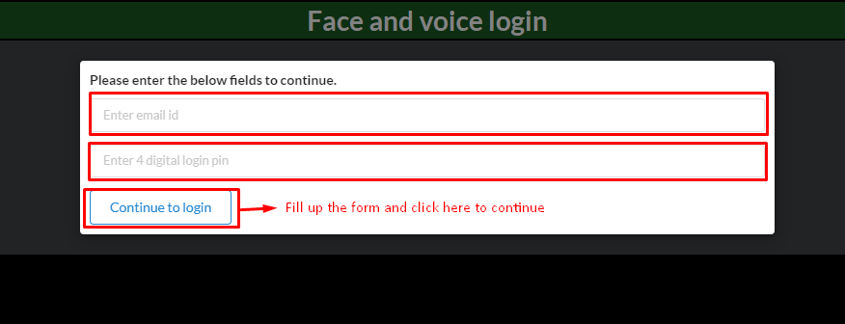

After verifying email and pin

1. Select a phrase. This phrase was taken while registration.

2. Click here to start recording.

3. Click here to stop recording.

4. Click here o verify face and voice.

5. Click here to reset camera.

